Q1. I cannot log in to its Web UI. What should I do?
- Verify that your terminal device (notebook, smart phone, iPad, etc.) is connecting to 4G185.
- Clear the cookies and caches of the browser you launch.
- Close all browsers and reopen one.
- Verify that your terminal device has obtained an IP address within the range of 192.168.0.2~192.168.0.253 (default).
- Verify that you’ve entered the correct login IP address 192.168.0.1 (default).
Q2. I cannot access the Internet. What should I do?
- Verify your USIM/SIM is prepaid and has enough balance.
- Verify your device is always in the valid range.
- Verify you input the correct pass phrase (WiFi key) when connecting to this mobile hotspot’s SSID (WiFi name).
- Verify that you input the default PIN code of SIM card if your service provider has provided you with a PIN code.
- Close firewall of your computer.
Q3. When the device is connected via the USB cable, the driver of this device isn’t installed automatically. What should I do?
- Restart your PC or notebook.
- Unplug the USB cable and plug it again.
- Click Open folder to view files, click the 4G MiFi driver setup program and then follow onscreen instructions to install the program.
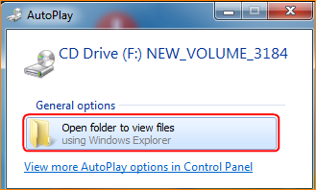
- On your desktop, double click Computer (in Windows 7 OS), locate the CD driver and double click it to install the program.
